## PROJECT REPORT

# **COMPUTER ENGINEERING DEPARTMENT**

# **(CE-409L)**

## FALL SEMESTER 2023



### **Submitted By:**

**HASEEB JAVED 2020-CE-129**

**WAJAHAT AHMED 2020-CE-142**

**SYED HAZIQ AHMED**  **2020-CE-143**

**ZAINAB RIZWAN 2020-CE-161**

**Submitted To:**

**Lab Teacher:** Miss Safina Soomro

**Course Teacher:** Miss Huma Hasan Rizvi

***TABLE OF CONTENT***

**ACKNOWLEDGEMENT**

# 

**ABSTRACT**

**SOFTWARE REQUIREMENTS SPECIFICATIONS(SRS)**

**WORKING**

**ADVANTAGES**

**OUTPUT**

**CONCLUSION**

**ACKNOWLEGDGMENT**

We express our heartfelt gratitude to all individuals who played a significant role in our "Simulation and Modeling" project, conducted under the guidance of Miss Safina Somroo.

Acknowledging the collaborative nature of technical projects, we appreciate Miss Safina Somroo for her guidance and support throughout this endeavor. Her initiative and insights have been instrumental in the success of our project, providing valuable perspectives on simulation and modeling.

We extend our thanks to our institution for its unwavering support, which has significantly contributed to the development of our project.

Our sincere appreciation goes to everyone who, directly or indirectly, contributed to shaping our thoughts and fostering the evolution of our project. Your assistance and encouragement have been invaluable.

We are grateful for the collective efforts and support received, acknowledging Miss Safina Somroo and all those who played a role in the success of our Simulation and Modeling project.

**ABSTRACT**

The "Spotify Simulation System" is an innovative project developed using Arena software to simulate user interactions within the music streaming realm. This endeavor seeks to unravel intricate patterns in user behaviors, offering a comprehensive understanding of how users interact with the Spotify app. Through meticulous simulation, the project aims to identify areas for optimization, enhance app functionalities, and ultimately elevate user satisfaction.

By employing Arena software, the simulation delves deep into user experiences, providing valuable insights into app usage patterns, feature preferences, and potential pain points. The project's focus on data-driven decision-making allows for targeted improvements, ensuring that the Spotify app remains at the forefront of user expectations. This synthesis of simulation technology and music streaming showcases the potential of Arena software in refining digital experiences and advancing user-centric innovations in the dynamic landscape of music applications.

**SPOTIFY APP SIMULATION SYSTEM**

**TABLE OF CONTENTS**

1. **INTRODUCTION ……………………………………………………………………………..**  Pages
   1. PURPOSE ………………………………………………………………………………………………………….
   2. SCOPE …………………………………………………………………………………………………………
   3. DEFINITION …………………………………………………………………………………………………………
   4. REFERENCES …………………………………………………………………………………………………………
   5. OVERVIEW …………………………………………………………………………………………………………
2. **OVERALL DESCRIPTION …………………………………………………………………..** Pages
   1. PRODUCT PRESPECTIVE ………………………………………………………………………….
   2. PRODUCT FUNCTIONS ………………………………………………………………………….
   3. USER CHARACTERISTICS ………………………………………………………………………….
   4. CONSTRAINTS ……………………………………………………………………….…
   5. ASSUMPTIONS & DEPENDENCIES ……………………………………………………………………….…
3. **SPECIFICATION REQUIREMENTS ……………………………………………………..** Pages
   1. EXTERNAL INTERFACE ……………………………………………………………
   2. FUNCTIONS ……………………………………………………………
   3. PERFORMANCE REQUIREMENTS ……………………………………………………………
   4. DESIGN CONSTRAINTS ……………………………………………………………
   5. SOFTWARE SYSTEM QUALITY ATTRIBUTES ……………………………………………………………
4. **INTRODUC TION**
   1. Purpose:

Developing the Spotify App Simulation System using Arena software aims to optimize user interactions, system efficiency, and resource utilization within the app. The goal is to enhance the user experience and identify areas for improvement.

* 1. Scope:

The project focuses on simulating user interactions in the Spotify App, examining user behavior, system response, and performance under various scenarios. The insights gained will inform decisions for potential enhancements.

* 1. Definition:

Key terms like "simulation," "user interactions," and "Arena software" are defined to establish clear communication and understanding among stakeholders throughout the project.

* 1. References:

1.5 Overview:

The project overview provides a concise summary of goals, the chosen simulation tool (Arena software), and anticipated outcomes, setting the stage for further exploration.

1. **OVERALL DESCRIPTION**
   1. Product Prospective:

The Spotify App Simulation System, developed using Arena software for the Simulation and Modeling course, offers a comprehensive outlook on the simulation of a music streaming platform. It provides insights into the dynamic nature of user interactions, content delivery, and system performance within the simulated environment.

* 1. Product Functions:

The simulation system encompasses key functions essential for a music streaming platform, including user engagement modeling, content recommendation algorithms, and backend system operations. It replicates the functionalities of the Spotify app, allowing for the analysis of user behavior, playlist generation, and system response to varying loads.

* 1. User Characteristics:

Designed to emulate diverse user characteristics, the simulation accommodates varying preferences, usage patterns, and interaction styles. It considers factors such as user demographics, music genre preferences, and device-specific behaviors to provide a realistic representation of user diversity within the simulated environment.

* 1. Constraints:

While the simulation strives for realism, it operates within certain constraints inherent to the modeling process. These constraints may include simplifications in user behavior models, assumptions about network conditions, and limitations in replicating the full complexity of a real-world streaming service.

* 1. Assumptions & Dependencies:

The simulation relies on certain assumptions related to user behavior trends, content popularity dynamics, and system scalability. Additionally, dependencies on Arena software for accurate modeling and simulation execution are integral to ensuring the reliability and relevance of the results.

1. **SPECIFIC REQUIREMENTS**
   1. External Interface:

The Spotify App Simulation System interfaces externally with the Arena simulation software, leveraging its capabilities to model and analyze complex interactions within the music streaming environment. This external interface is crucial for ensuring the accuracy and effectiveness of the simulation, allowing for seamless integration of user inputs, system responses, and environmental variables.

* 1. Functions:
  2. Performance Requirements:

The performance requirements of the simulation system revolve around the efficient execution of the simulation models, encompassing factors such as processing speed, data accuracy, and scalability. Meeting these requirements is essential for obtaining meaningful insights into the dynamic aspects of user engagement, content delivery, and system efficiency.

* 1. Design Constraints:

The design of the simulation system operates within certain constraints dictated by the limitations of the modeling approach. These constraints may include simplifications in the representation of user behaviors, assumptions about network conditions, and trade-offs made to balance realism with computational feasibility.

* 1. Software System Quality Attributes:

Key quality attributes, including reliability, accuracy, and scalability, characterize the software system. The simulation's reliability is crucial for generating trustworthy insights, accuracy ensures fidelity to real-world scenarios, and scalability allows the system to handle varying levels of complexity and user interactions effectively. These attributes collectively contribute to the overall robustness of the Spotify App Simulation System.

**WORKING**

* Model:

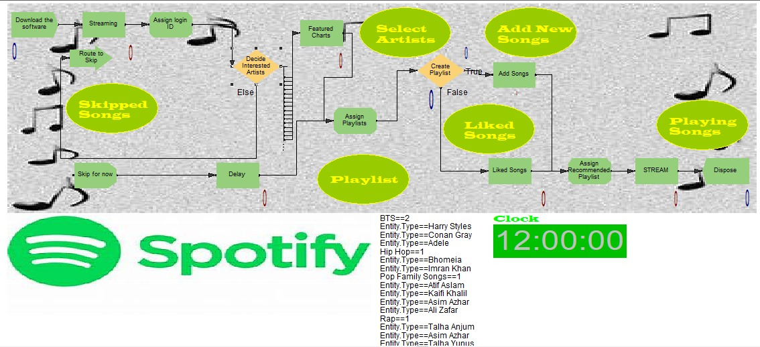

* Working Model:
* Report:

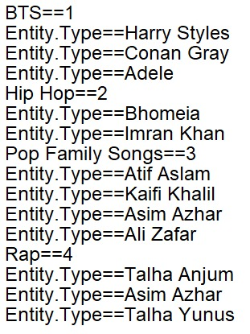

* Decide:

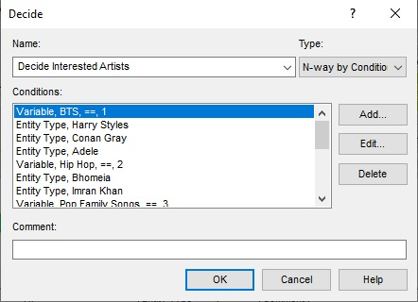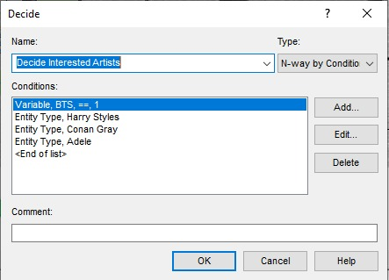

* Process:

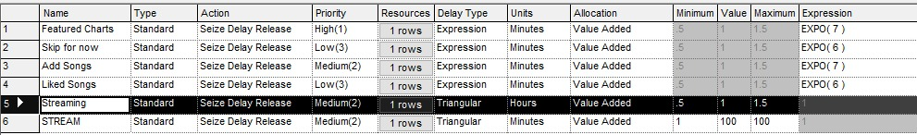

* Assign:

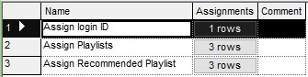

* Decision:

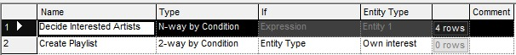

**ADVANTAGES**

The Spotify Simulation System, powered by Arena software, brings significant advantages to the field of Simulation and Modeling:

* **Behavior Analysis:** Deep insights into user interactions and preferences enhance understanding.
* **Optimization Opportunities:** Identification of areas for app improvement, refining design and functionality.
* **Scenario Testing:** Robust testing under various conditions ensures app resilience and performance.
* **Data-Driven Decisions:** Informed choices for feature updates and alignment with user expectations.
* **Predictive Analytics:** Anticipation of future trends, staying ahead in the competitive music streaming landscape.

**OUTPUT**

The Spotify Simulation System, developed using Arena software for the Simulation and Modeling course, brings strategic advantages to app optimization. By analyzing user engagement and system performance, it guides informed decisions, enabling adjustments for improved responsiveness. The simulation's output serves as a valuable roadmap for enhancing the Spotify app's user experience and staying attuned to dynamic market expectations.

**CONCLUSION**

In conclusion, the **Spotify Simulation System**, developed through the application of **Arena software** in the realm of Simulation and Modeling, stands as a powerful tool for the enhancement and evolution of the **Spotify app**. Its ability to dissect user behaviors, optimize functionalities, conduct thorough scenario testing, and provide data-driven insights positions it at the forefront of informed decision-making. The predictive analytics offered by this simulation system equip Spotify with the foresight needed to adapt to dynamic market demands, ensuring a user-centric, competitive, and innovative music streaming experience.